Welcome to the CiteRight Quick Start Tutorial!
Over the course of the next eight pages, you’re going to learn a few basics of our tool.
This Quick Start Tutorial will empower you to create citations, hyperlinks, and more at the click of a button! Are you ready to supercharge your research and drafting workflow?
Skip through to different sections using the table below or just start scrolling!

No need to print this document. Follow all the steps directly in Microsoft Word!

Contents
To navigate to a section, hold down “Ctrl” and click on a heading. Or press Ctrl+F to keep your Navigation pane open.
The Basics (5 minutes)
1. Accessing the Word Extension 2
2. Navigating In-text Citations and Footnotes 3
3. Changing your Pinpoints 4
4. Citing Your First Case! 5
Getting Into It (8 minutes)
5. Modifying a Case 6
6. Hyperlinking Citations 7
7. Formats (Ibids, Supras, Short Forms) 8
8. List Citations 9
9. Inserting a Table of Authorities 9
10. Next Steps 10

Need help? Talk to a human!
Call us: 1-888-349-9842
E-mail us: support@citeright.net

Accessing the Word Extension
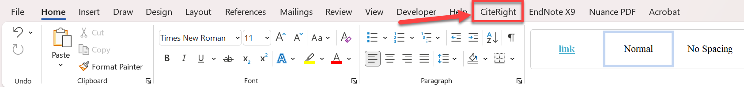
After CiteRight has been installed onto your device, you will see the CiteRight tab on the Microsoft Word ribbon at the top of your window. Click on this tab.
If you are not seeing the CiteRight tab, click here for more instructions, or reach out to your IT team.

Next, click on Open CiteRight, located on the left side of the ribbon.
If the button is disabled, your document may have opened in Compatibility Mode.

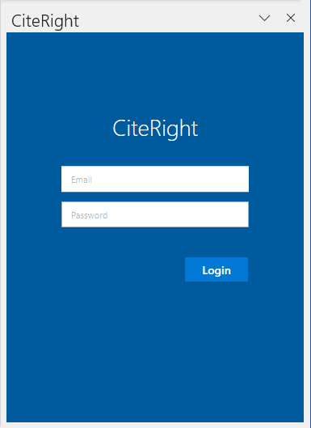
You will see the blue CiteRight side panel pop up on the right side of your screen, prompting you to log in. It will look like this:

If you need help creating your password or see the ‘email or password is invalid’ message pop up, click here to reset your password.
Word Tip: Any Word Add-In with a side panel like CiteRight can be resized or even moved onto a separate monitor!

Now that you are logged into the side panel, let’s begin!

Navigating In-text Citations and Footnotes
Using the sample citations, let’s see how each citation links to the case text in the side panel. Click on this in-text citation and see what happens in the side panel!

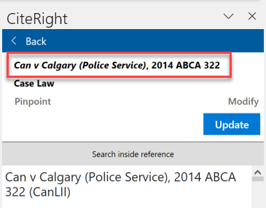
Click here! Can v Calgary (Police Service), 2014 ABCA 322

Selecting the citation immediately opens the case text in side panel. It should look like this:

If you scroll through the case text, you’ll begin to see individual paragraphs. Feel free to try it before continuing!
This is particularly helpful during your review process!

Now, click on a citation that includes pinpoints.

Click here! AIC Limited v Fischer, 2013 SCC 69, [2013] 3 SCR 949 at para 10.

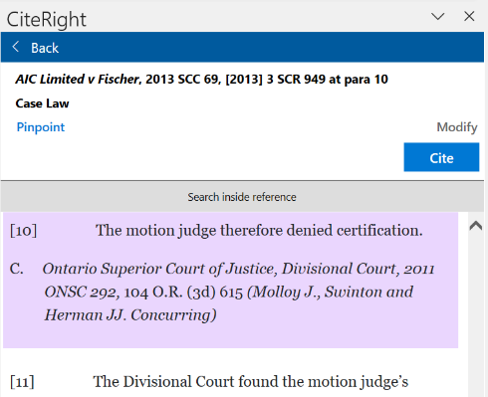
Your side panel will immediately display the new case text. This time, since the citation references paragraphs 7-11, you will be brought to the first pinpointed paragraph of the text, highlighted in purple.

The side panel works for both in-text and footnote citations., Go ahead and try clicking directly on the footnotes below to see the same functions at work!
Our smart citations will automatically renumber and reorder themselves as you cite more or copy and paste throughout your document!

Changing your Pinpoints
Let’s use footnote 2 as our example. If you need to remove paragraph 9 from your pinpoints, there are two ways to go about it:
- Directly in the case text: Hover your curser over that paragraph. You’ll see a blue – para 9 button pop up on the upper right corner of the paragraph.
After clicking – para 9, the paragraph will no longer be highlighted.

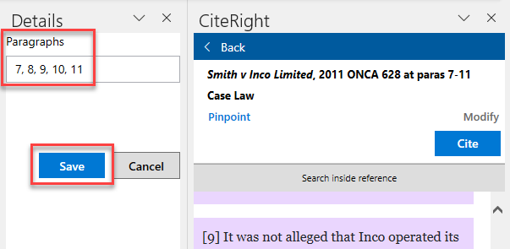
- Using the pinpoint button: After clicking on Pinpoint, another side panel will appear allowing you to edit pinpoints. Delete paragraph 9 from this list and then click Save.
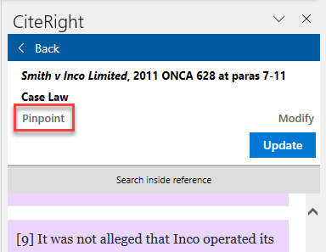

After using either of these two methods, you’ll see that the citation preview now says at paras 7-8, 10-11. Click the dark blue Update to update your footnote with the new pinpoints.
Note: if you have clicked somewhere else in your document, you may not see an Update button. If it says Cite here, it means that it will insert a new citation. Update means that you are selected on an existing citation and changing its pinpoints.
Scrolling up to the previous page, you will now see that footnote 2 has new pinpoints.
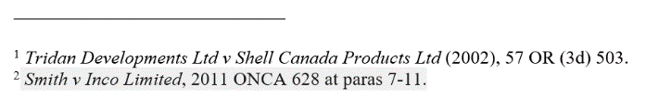
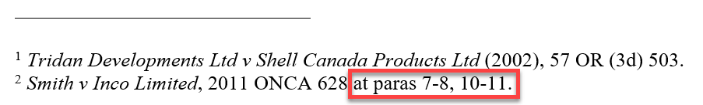
Before: After:

Citing Your First Case!
Now let’s try to create a new citation with a different case. If this is your very first time using CiteRight, you may not have saved a case yet. However, you have access to any and all cases that your colleagues have saved in the past. These are found in your Firm Library. To go there, click on < Back. Then, click Library under Firm Sources.
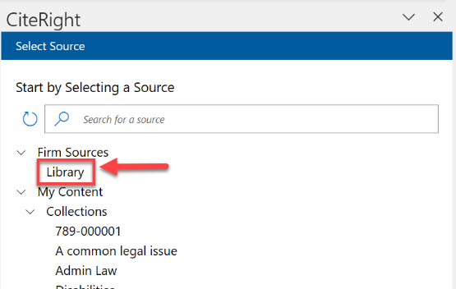
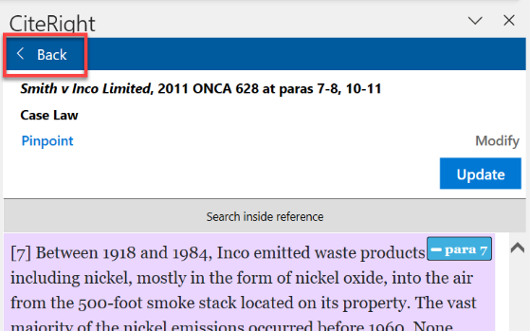

Next, click on the search tab at the top of the window and look for “Sault” (You can also use a case’s short form or citation). Once you find R. v. Sault Ste Marie, [1978] 2 SCR 1299, click on it to open the case.
Tip: click refresh if you have recently saved a case and it is not yet appearing.
Once you are viewing the case text in the side panel, you will see the Cite button in dark blue. Place your cursor on the paragraph below and then click Cite.
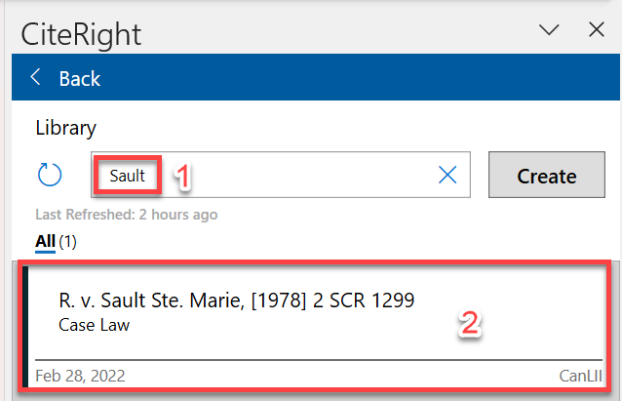
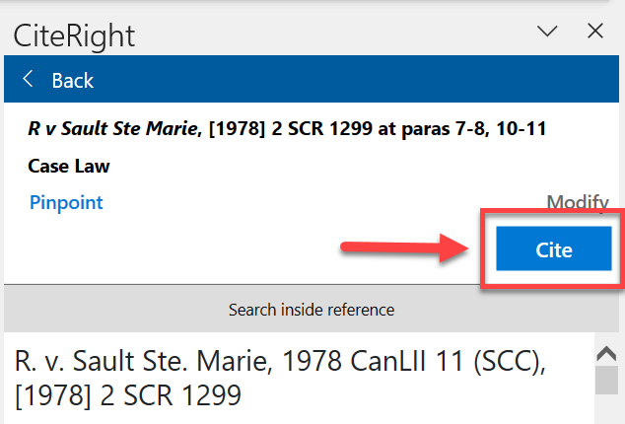

[Insert your citation here:]

After clicking Cite above, Footnote 3 will be inserted. You can always switch your citation style to in-text if you prefer. This can be done in the Preferences menu.

Modifying a Case
You can modify a citation’s content, formatting, short form, hyperlink, and pinpoint type.
Click here: Honda Canada Inc v Keays, 2008 SCC 39, [2008] 2 SCR 362 at para 5

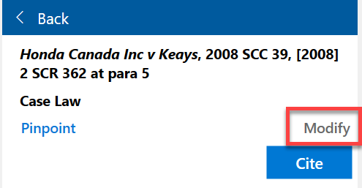
Your side panel will show the case text for the above case. In the side panel, click Modify.

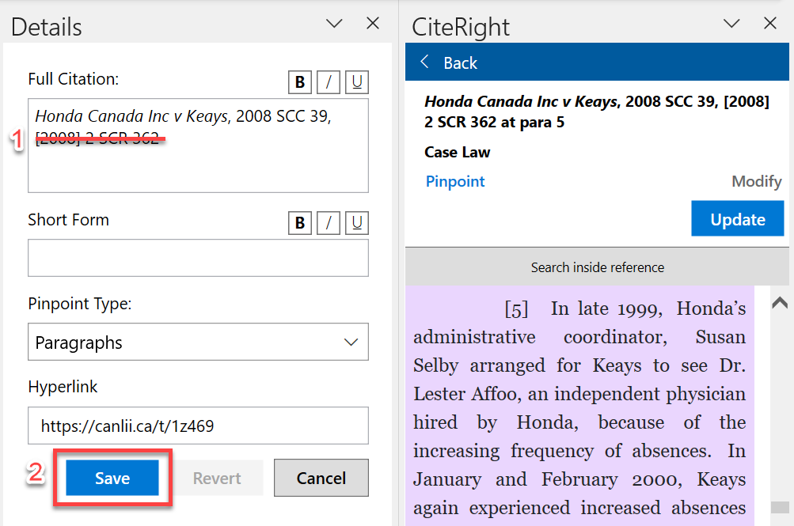
The modify menu will then appear next to your side panel. This contains fields for you to customize your full citation, short form, pinpoint type, and hyperlink. In this example, let’s remove the parallel citation. Once your modifications are done, click Save.

Now, look back at the above citation. The changes are immediately updated and will apply to any other citations to the same case throughout the document!

Before: After:

Check out our Helpdesk article to learn more about modifying your citations.

Hyperlinking Citations
Want to hyperlink all your citations? Click on the Preferences button on the Microsoft ribbon.
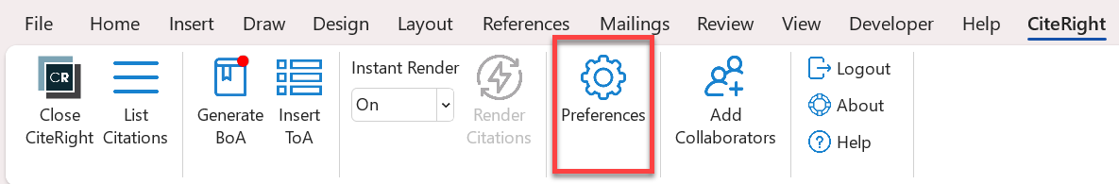

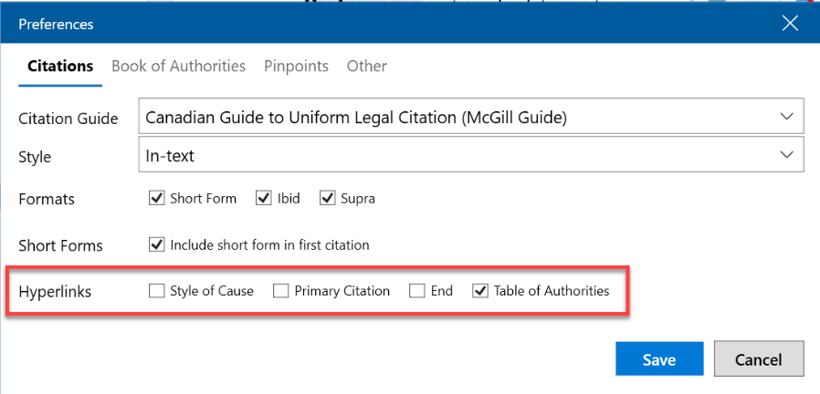
The Preferences window will appear in the middle of your screen.
You can change many document-wide preferences here, including hyperlinks!
You’ll see these example citations at the bottom of this page.

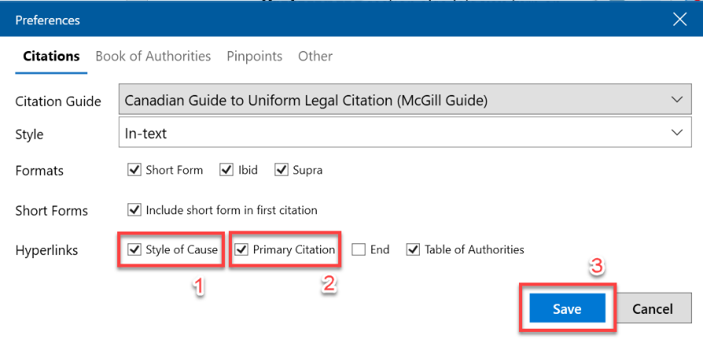
Let’s turn on hyperlinks in the Style of Cause and Primary Citation. Click on both boxes and then click Save.

You’ll see that all your in-text citations and footnotes are now hyperlinked!

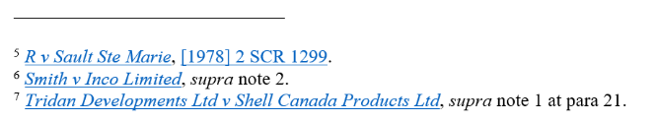
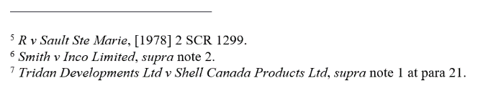
Before: After:

Formats (Ibids, Supras, Short Forms)
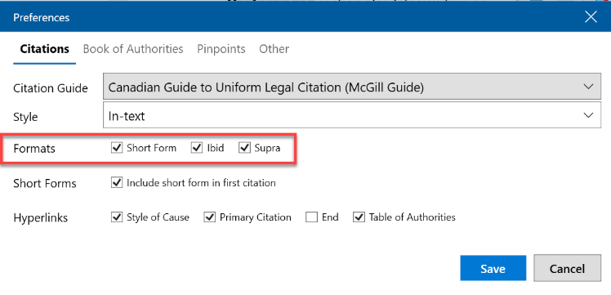
In addition to toggling hyperlinks, the Preferences section also lets you turn on and off ibids, supras, and short forms. To try this, open Preferences again.
You’ll see that ibids, supras, and short forms are selected by default. You can turn off whichever ones you would like and this will update all your existing citations throughout the document.
This means that not only are ibids and supras dynamically reorder as you work through the document, but they can be added or removed any time!

List Citations
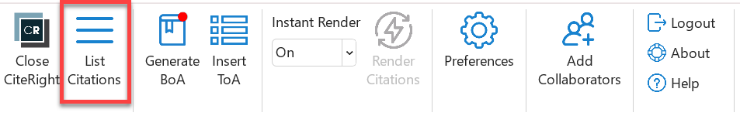
This feature is a great way to review your citations in order. To see a list of citations cited in this document, go back to the ribbon at the top and click List Citations.
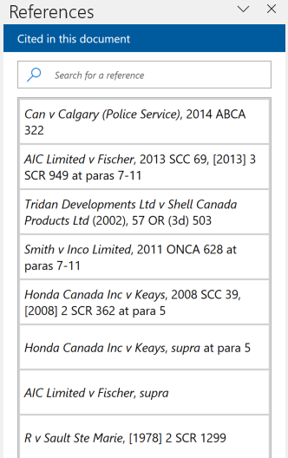
A References panel will pop up on the right, next to your CiteRight side panel. References will be listed in order of appearance. If you click anything in the panel, you’ll see both your document jump to where it’s referenced and your CiteRight panel reflect the case you clicked on.

Inserting a Table of Authorities
To insert a ToA (Table of Authorities), simply choose part of your document and click on Insert ToA.
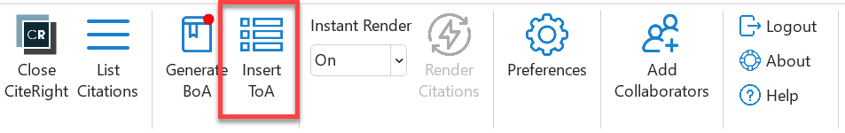

After clicking on Insert ToA, the ToA will appear at your selected area as seen below. Unlike citations, ToAs do not automatically update when you work through the document, so keep in mind to delete and reinsert your ToA when you make any changes to your citations.
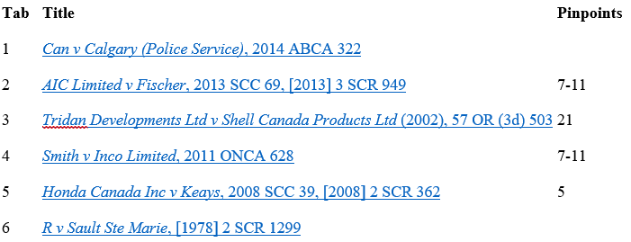

[Insert your Table of Authorities here:]

Next Steps
That’s it, you’ve just completed the CiteRight tutorial! There are plenty more amazing features to try out. Would you like to save your own cases? Or cite sources outside of case law? Check out some of these articles below to continue learning.
If you have any questions or would like help with getting started, our friendly support team is always here to assist. You can e-mail us at support@citeright.net or reply to our welcome email. We hope to hear from you soon!

To discover more, check out these helpdesk articles:
Saving a case
Not case law? Creating a custom reference
Book of Authorities: Overview
Inserting a block quote

Tridan Developments Ltd v Shell Canada Products Ltd (2002), 57 OR (3d) 503.
Smith v Inco Limited, 2011 ONCA 628 at paras 7-11.
Honda Canada Inc v Keays, supra at para 5.
AIC Limited v Fischer, supra.
R v Sault Ste Marie, [1978] 2 SCR 1299.
Smith v Inco Limited, supra note 2.
Tridan Developments Ltd v Shell Canada Products Ltd, supra note 1 at para 21.

