Welcome to the CiteRight Next Quick Start Tutorial!
Over the course of the next 15 minutes, you’re going to learn a few basics of our tool.
This Quick Start Tutorial will empower you to create citations, hyperlinks, and more at the click of a button! Are you ready to supercharge your research and drafting workflow?
Skip through to different sections using the table below or just start scrolling!
No need to print this document. Follow all the steps directly in Microsoft Word!

Contents
To navigate to a section, hold down “Ctrl” and click on a heading. Or press Ctrl+F to keep your Navigation pane open.
The Basics (5 minutes)
1. Accessing the Word Extension 2
2. Navigating In-text Citations and Footnotes 3
3. Changing your Pinpoints 4
4. Citing Your First Case! 5
Getting Into It (10 minutes)
5. Modifying a Reference 6
6. Editing a Specific Citation 7
7. Document-wide Preferences 7
8. List Citations 8
9. Inserting a Table of Authorities 9
10. Generate a Book of Authorities 10
11. Next Steps 10

Need help? Talk to a human!
Call us: 1-888-349-9842
E-mail us: support@citeright.net

Accessing the Word Add-In
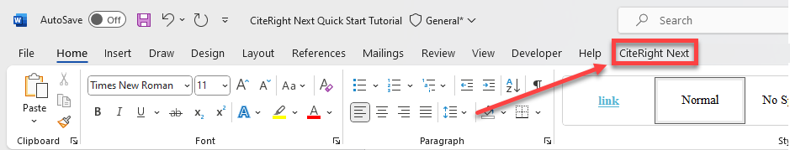
After CiteRight has been installed onto your device, you will see the CiteRight Next tab on the Microsoft Word ribbon at the top of your window. Click on this tab.

If you do not have it installed yet, add it from the Microsoft App Store, or reach out to your IT team.

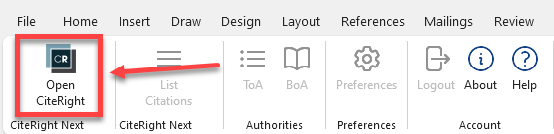
Next, click on Open CiteRight, located on the left side of the ribbon.

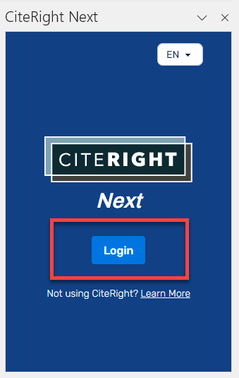
You will see the blue CiteRight side panel pop up on the right side of your screen, prompting you to log in. It will look like this:

If you need help creating your password or see the ‘email or password is invalid’ message pop up, click here to reset your password.
Word Tip: Any Word Add-In with a side panel like CiteRight can be resized or even moved onto a separate monitor!

Now that you are logged into the side panel, let’s begin!

Navigating In-text Citations and Footnotes
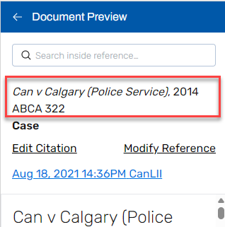
Using these sample citations, let’s see how each one connects to the content in the side panel.

Click here! Can v Calgary (Police Service), 2014 ABCA 322

Selecting the citation immediately opens the case text in side panel. It should look like this:

If you scroll through the case text, you’ll begin to see individual paragraphs. Feel free to try it before continuing!
Tip: If anything doesn’t seem to be working as expected, a quick fix is to reload the side panel.
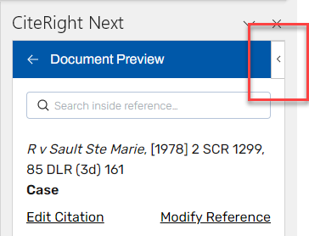
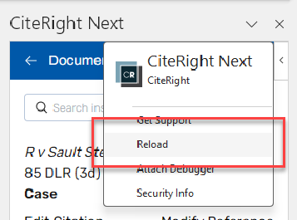
Hover and click on the side arrow.
Click reload.

Now, click on a citation that includes pinpoints.

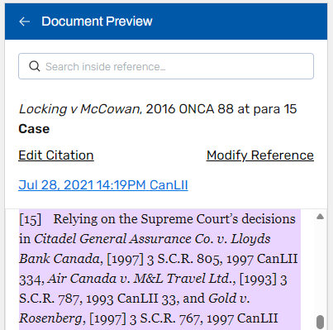
Click here! Locking v McCowan, 2016 ONCA 88 at para 15

Your side panel will immediately display the new case text. This time, since the citation references paragraph 15, you will be brought to that pinpointed paragraph of the text, highlighted in purple.
The side panel works for both in-text and footnote citations. Go ahead and try clicking directly on the footnotes below to see the same functions at work!

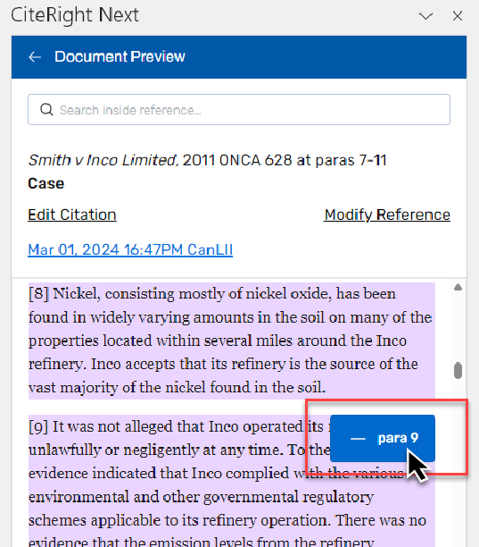
Changing your Pinpoints
There are two ways to edit your pinpoints. Let’s use footnote 2 as our example. We’ll try removing paragraph 9 from your pinpoints, using both methods:
- Directly in the case text: Hover your curser over that paragraph. You’ll see a blue – para 9 button pop up on the upper right corner of the paragraph.
After clicking – para 9, the paragraph will no longer be highlighted.
Scrolling up to the previous page, you will now see that footnote 2 has new pinpoints: 7-8, 10-11.

- Using the pinpoint button: After clicking on Edit Citation, a window will appear allowing you to edit pinpoints. Delete paragraph 9 from this list and then click Save.
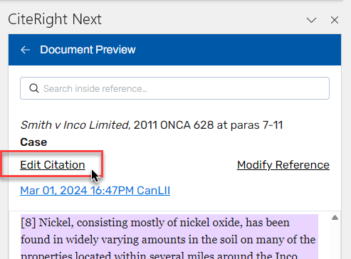
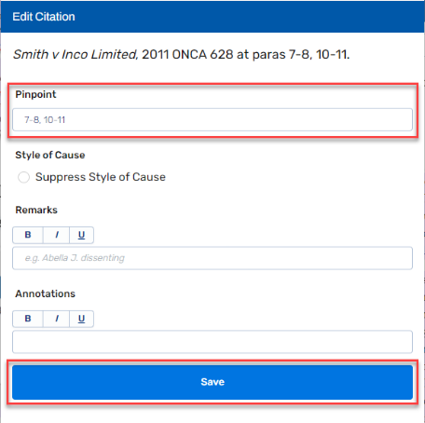

Go ahead and try adjusting your pinpoints with either of those two methods before moving on!
Note: If you were using an older version of CiteRight prior to using CiteRight Next, you may remember an Update button. This is no longer needed! Your pinpoints will update right away.
You may also notice more features in this window – we’ll go over those in Section 6.

Citing Your First Case!
Now, let’s try inserting a new citation with a different case. If this is your very first time using CiteRight, you may not have saved a case yet. However, you have access to any and all cases that your colleagues have saved in the past. These are found in your Firm Library. To go there, click on the back button < until you reach the All Sources page. Then, click Library under Firm Sources.
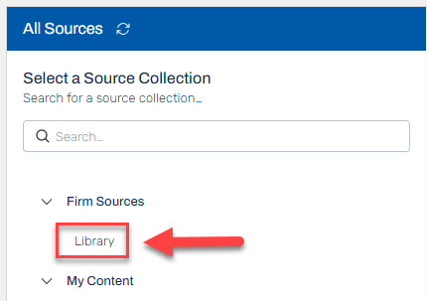
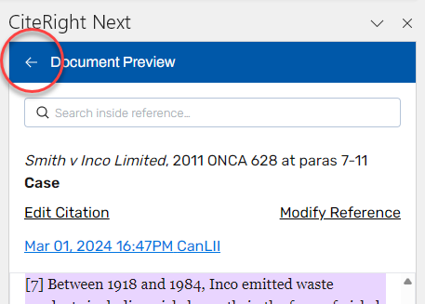


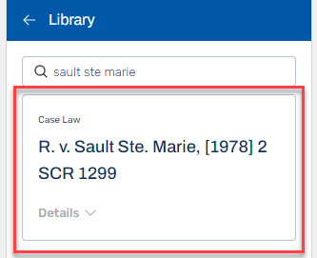
Next, click on the search tab at the top of the window and look for “Sault Ste Marie” (You can also use a case’s short form or citation). Once you find R. v. Sault Ste Marie, [1978] 2 SCR 1299, click on it to open the case.
Tip: click the refresh button if you have recently saved a case and it is not yet appearing.

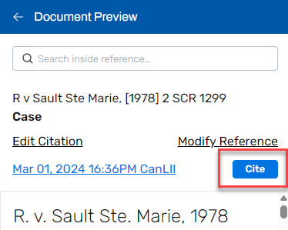
Once you are viewing the case text in the side panel, you will see the Cite button in dark blue. Place your cursor on the paragraph below and then click Cite. Try inserting your citation at the end of this sentence.
Click there and then click the Cite button!

After clicking Cite above, Footnote 3 will be inserted. You can always switch your citation style to in-text if you prefer. This can be done in the Preferences menu.
Our smart citations will automatically renumber and reorder themselves as you cite more or copy and paste throughout your document!

Modifying a Reference
You can modify a reference’s content, short form, hyperlink, and more through Modify Reference. Changes in this menu will apply to all citations to this case throughout your document!
Click here: Honda Canada Inc v Keays, 2008 SCC 39 at para 5
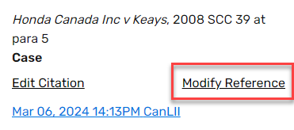
Your side panel will show the case text for the above case. In the side panel, click Modify Reference.
The Modify Details menu will pop up in a new window. This contains fields for you to customize the reference:
- Style of cause
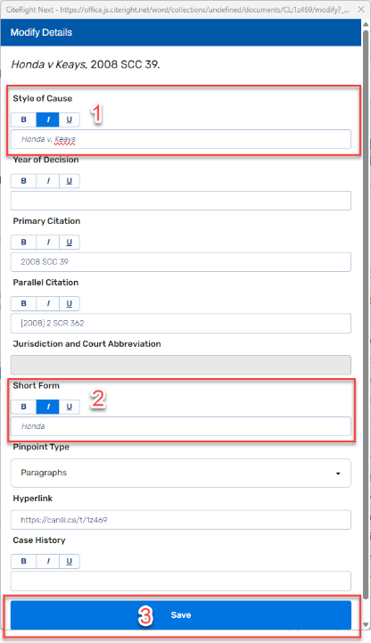
- Year of decision (only if needed*)
- Primary citation
- Parallel citation (only if needed*)
- Jurisdiction and Court Abbreviation (only if needed*)
- Short form
- Pinpoint type
- Hyperlink
- Case history
*If the primary citation is a neutral citation, these fields will be disabled as they won’t be displayed in your citation.
document!

In this example, let’s remove the “Canada Inc” from the Style of Cause and add “Honda” as the Short Form. Once your modifications are done, click Save.
Now, look back at the above citation and at footnote 4 below!
Before: After:
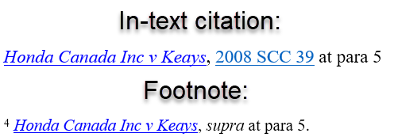
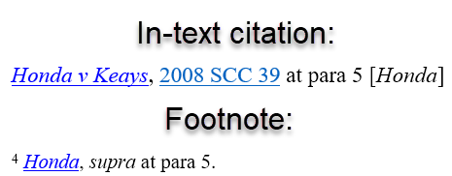

Check out our Helpdesk article to learn more about modifying your references!

Editing a Specific Citation
Aside from changes to case details, you may have more specific edits that you want to make to a particular footnote or in-text citation. To change things like pinpoints, suppressing the style of cause, annotations, and remarks, you can use the Edit Citation menu. Changes in this menu will only apply to one citation at a time.
Click here: Ibid
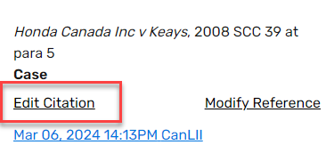
Your side panel will show the same case text as in the previous section since it is a citation to the same case. Click Edit Citation.
The Edit Citation menu will pop up in a new window. This contains fields for you to customize the citation:
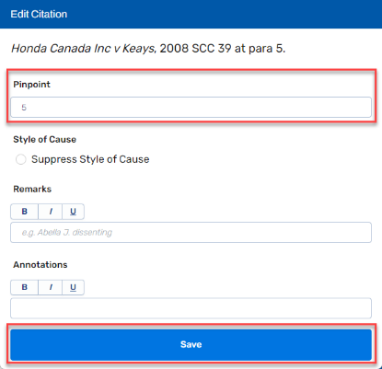
- Pinpoints
- Style of cause (option to suppress it)
- Remarks
- Annotations

Let’s change the pinpoints, since style of cause, remarks and annotations don’t apply to an ibid. Once done, click Save.
Now, look back at the above citation! We have updated it with your new pinpoints, while other citations to the same case are unaffected.
Check out our Helpdesk article to learn more about

Check out our Helpdesk article to learn more about editing your citations!

Document-wide Preferences
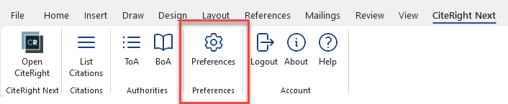
Want to remove hyperlinks from all of your citations? Or turn off ibids and supras? All document-wide settings like this are found in the Preferences menu. Click Preferences in the top ribbon.

The Preferences window will appear in the middle of your screen. While there are many customizations you can make in this menu, let’s focus on ibids and supras for now.
Let’s turn off ibid, supra, and short form in the Formats section. Click on both boxes to remove them and then click Save. You’ll see that all your citations are now in full form
You’ll see a few example citations at the bottom of this page. See how the changes in Preferences affects those citations.
1. Open Preferences. 2. Remove ibid, supra, and short form.
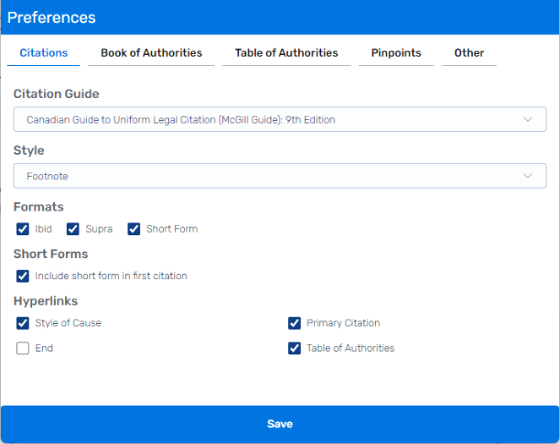
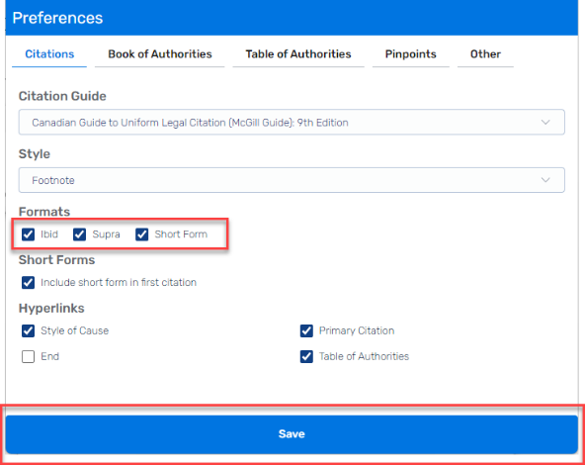

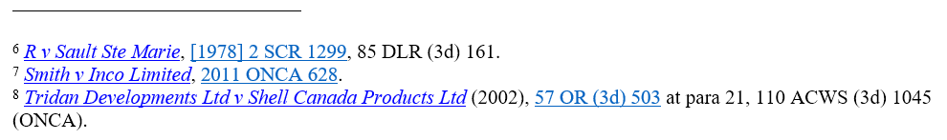
Your footnotes at the bottom of this page should look like this:

List Citations
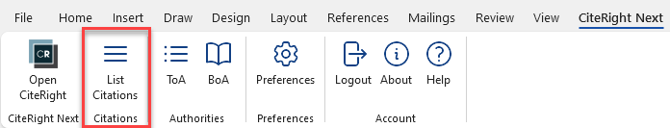
List Citations is a great way to review your citations in order. To see a list of citations cited in this document, go to the ribbon at the top and click List Citations.

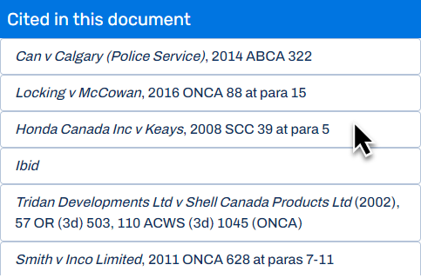
The Cited in this document window will pop up. All of your references will be listed in order of appearance. If you click on those items, you’ll see both your document jump to where it’s referenced and your CiteRight side panel reflect the case you clicked on. Try navigating through all of the citations throughout this document!

Inserting a Table of Authorities
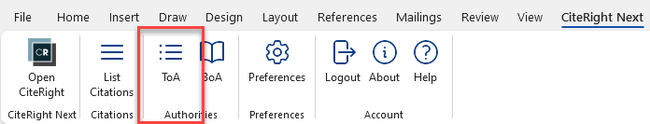
To insert a ToA (Table of Authorities), simply click on the blank space below and then click ToA.

After clicking ToA, it will be inserted at your selected area like the screenshot below.
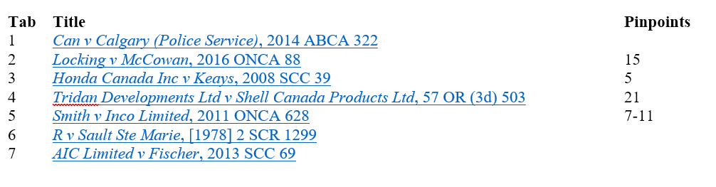

Insert your Table of Authorities here:

Note: Unlike citations, Tables of Authorities and Books of Authorities do not automatically update when you work through the document, so keep in mind to delete and reinsert your ToA, or generate a new BoA, whenever you make any changes to your citations. That includes deleting, inserting, or moving your citations around.

Generating a Book of Authorities

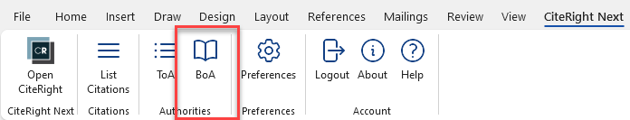
Lastly, try generating a BOA (Book of Authorities). For the simplest version, just click BoA.

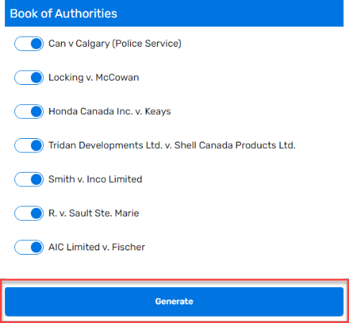
CiteRight will then ask you which sources you want to include or exclude from your BOA. By default, all of your sources will be included. Let’s leave them all in and click Generate.

Lastly, you will need to name and save the BOA as a PDF file. Once you’ve saved it, your PDF will be created, and your Word document will have tab markers inserted after each citation!
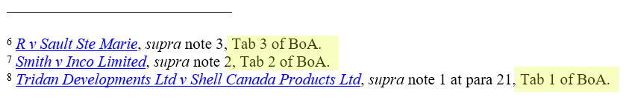
This is what your footnotes will look like after generating a BoA:

There are plenty more features of the BOA that you can customize by going to Preferences!

Next Steps
That’s it, you’ve just completed your CiteRight Next tutorial! There are plenty more amazing features to try out. Would you like to save your own cases? Or cite sources outside of case law? Check out some of these articles below to continue learning.
If you have any questions or would like help with getting started, our friendly support team is always here to assist. You can e-mail us at support@citeright.net or reply to our welcome email. We hope to hear from you soon!
To discover more, check out these Helpdesk articles:
Saving a case
Not case law? Creating a custom reference
Book of Authorities: Overview
Inserting a block quote

Tridan Developments Ltd v Shell Canada Products Ltd (2002), 57 OR (3d) 503, 110 ACWS (3d) 1045 (OR).
Smith v Inco Limited, 2011 ONCA 628 at paras 7-11.
Honda Canada Inc v Keays, supra at para 5.
AIC Limited v Fischer, 2013 SCC 69.
R v Sault Ste Marie, [1978] 2 SCR 1299, 85 DLR (3d) 161.
Smith v Inco Limited, supra note 2.
Tridan Developments Ltd v Shell Canada Products Ltd, supra note 1 at para 21.

